|  |  |
| --- | --- |
| 2019 – 03 March | Lion’s Tales  *Newsletter of the Cedar Rapids Noon Lions Club of Cedar Rapids, Iowa* |
| **Officers:**  President: Kristin Glockhoff  1st VP: Scott Lindsley  2nd VP: Mark Stewart  Secretary: Mary Doyle  Treasurer: Don Magee  2019: Margaret Debner  Ron Mustaine  2020: Walt Hartman  Dean Thomas  2021: Dennis Egel  Gary Glockhoff  Membership: Terry Durham  Lion Tamer: Bill Severa  Tail Twister: Ron Mustaine  Past President: Greg Reed  **COMMITTEE CHAIRS:**  Program: Greg Reed  KidSight: Barb Taylor  Mary Ann Dawson  Vision: Scott Lindsley  Rich Rheinschmidt  Hearing: Bill Jurgensen  John Swenson  Pat Gourley (hearing aids)  Wright School: Margaret Debner  Linda Fisher  Diabetes: Margaret Debner  Hunger: Walt Hartman  Dean Thomas  Environment: Ron Mustaine  Childhood Cancer: Dennis Egel  Gary Glockhoff  School Outreach: Mark Stewart  Variety Show: Jan Federer  Bike Ride: Gary Glockhoff | President’s Message: March - in like a LION, out like a lamb… let’s hope the weather will be more conducive to travel and school attendance in March than it was in February!  In past years, we’ve often held a chili supper fundraiser in March. This year, we are trying something new - a NON-EVENT fundraiser that will exercise your check-writing arm rather than your standing muscles. Members should have received, either at the February 14 meeting or in the mail, our non-event fundraiser letter.  We hope you will respond generously as we raise money for our charitable account.  March is also the month the nominating committee looks for officers for the coming year. We also attend the District 9EC Spring Convention (March 23 in DeWitt) and make plans for our club’s April 26th awards banquet. March 3 is World Hearing Day and the month of March is Eye Donor Awareness Month. Look for additional newsletter articles in this issue about these two Lions global service areas.  In service,  Kristin  *“Indoors or out, no one relaxes in March, that month of wind and taxes,*  *the wind will presently disappear, the taxes last us all the year.”*  *- Ogden Nash*  **Non-Event Club Fundraiser!**  https://lh5.googleusercontent.com/4GUirt550pmH9XGYlu_3Lza7gyvaR7_G37aZ7Un4mRvYehWAb6s354q-sA3JbGcV1aXGWVxFpugmLOSOAZsIVFguELKZmNFBdyCtuwrRnvILYQUeTuEXKWcQMXmZ7BSDN-BcQU2Qhttps://lh5.googleusercontent.com/4GUirt550pmH9XGYlu_3Lza7gyvaR7_G37aZ7Un4mRvYehWAb6s354q-sA3JbGcV1aXGWVxFpugmLOSOAZsIVFguELKZmNFBdyCtuwrRnvILYQUeTuEXKWcQMXmZ7BSDN-BcQU2Qhttps://lh5.googleusercontent.com/4GUirt550pmH9XGYlu_3Lza7gyvaR7_G37aZ7Un4mRvYehWAb6s354q-sA3JbGcV1aXGWVxFpugmLOSOAZsIVFguELKZmNFBdyCtuwrRnvILYQUeTuEXKWcQMXmZ7BSDN-BcQU2Qhttps://lh5.googleusercontent.com/4GUirt550pmH9XGYlu_3Lza7gyvaR7_G37aZ7Un4mRvYehWAb6s354q-sA3JbGcV1aXGWVxFpugmLOSOAZsIVFguELKZmNFBdyCtuwrRnvILYQUeTuEXKWcQMXmZ7BSDN-BcQU2Qhttps://lh5.googleusercontent.com/4GUirt550pmH9XGYlu_3Lza7gyvaR7_G37aZ7Un4mRvYehWAb6s354q-sA3JbGcV1aXGWVxFpugmLOSOAZsIVFguELKZmNFBdyCtuwrRnvILYQUeTuEXKWcQMXmZ7BSDN-BcQU2Q  Have you made your contribution to our non-event fundraiser yet? Your donations help fund our budgeted service activities which include Wright School Partnership, Lions Clubs International Foundation, Iowa Lions Foundation, eye exams & glasses, hearing assistance, Camp Hertko Hollow (diabetes camp), Leader Dog programs, Youth Exchange Camp, the 9EC Care & Share fund, and our support of a Student Volunteer in Optometric Service to Humanity. |
| **Program Chairs**:  August: Russell/Higdon  September: Glockhoff’s  October: Ralph Wasik  November: Glockhoff’s  December: Hartman / Reed  January: Reed / Hartman  February: Al Huneke  March: Jeff Busbee  April: Jan Federer  May: Dennis Egel  June: Gary Lindsey  July: Taylor/Dawson  **Greeters**:  August: Glockhoff’s  September: Siebenmann  October: MaryAnn Dawson  November: Bill Jurgensen  December: Walt Hartman  January: Mark Stewart  February: Barb Taylor  March: Al Huneke  April: Terry Durham  May: Charlie Gallaher  June: Jan Federer  July: Dennis Egel  **Tail Twisters**:  August: John Swenson  September: Dean Thomas  October: Greg Reed  November: Gary Glockhoff  December: Jan Federer  January: Ron Mustaine  February: Ralph Wasik  March: Elaine Brown  April: Dennis Egel  May: Walt Hartman  June: Taylor / Dawson  July: K.A. Nanjappa | March Programs – Jeff Busbee  |  |  | | --- | --- | | 07 | “African Hope” Kellie Lala | | 14 | “Moon Talk-The Inside Story” and “Live From the Moon” preview with Rod Blocksome | | 21 | Jeff says it’ll be a great program | | 28 | Jeff says ditto |  March Greeter – Al Huneke **Instructions:** A greeter signs up for one month, and it is his job to make visitors feel welcome. The greeter **arrives by 11:45** and **waits to get his food**; makes sure to **welcome any visitor and make introductions** to the president and other officers. Locate the laminated **visitors meeting agenda sheet** so they have the words to the first & fourth verses of the song. Provide them a **club brochure**. Thanks for helping grow the club!  **March Tail Twister: Elaine Brown**  **March Birthdays:**  7th - Richard McGaughy  23rd Julie Facion     |  |  | | --- | --- | |  |  | |  |  | |  |  |   **New Member:**  *See your name in print as the sponsor of a new member. Have you passed out any Lions Club business cards lately?* |

**Volunteer for a Lions Club Committee**

What do you enjoy doing? What are your volunteer interests? Lions Club probably has a committee where your talents will shine!

|  |  |
| --- | --- |
| * 100 Year Celebration (May 2020) | * Awards Banquet (April 26, 2019) |
| * Fundraising | * Marketing |
| * Variety Show (Sept 2019) | * Wright School |
| * Childhood Cancer | * School Outreach |
| * Diabetes | * Hunger |
| * Tech (Website, Facebook) | * Environment |
| * Newsletter | * Hearing |
| * Vision | * KidSight |

Please volunteer to help with a Lions committee that speaks to your heart for service.

**Premier Chamber Orchestra Concert**

In January, Cedar Rapids Noon Lions Club members provided funds to support two scholarships for the newly-formed Premier Chamber Orchestra. The orchestra provides opportunities for 22 well-qualified stringed instrument players in grades 9-12 corridor schools to join professional musicians in presenting classical music concerts. Each scholarship will pay the costs for one student to participate in one of the concerts. **The first concert will be held March 11, 2019 at the Cedar Rapids Library Whipple Auditorium.**

### **2018-2019 INAUGURAL SEASON**

Spring Concert - March 11, 2019

7:00pm, Ballantyne Auditorium (Kirkwood College)

Beethoven, Symphony No. 5 in C minor, Op. 67

Tickets can be purchased on-line at <https://www.premierchamberorchestra.com>.

**District 9EC Spring Convention is March 23**

The DeWitt Noon Lions, DeWitt Nite Lions and the Low Moor Lions are anxious to see all Iowa District 9EC Lions at the **9EC spring convention** in **DeWitt, Iowa** on **Saturday, March 23, starting at 8:00am**.  Meet International Director Mark Lyon and his wife, Lion Lyn. There will be presentations about human trafficking, diabetes, and more. The cost is $20 per person and includes rolls/coffee and a buffet lunch. Join district 9EC Lions for what is sure to be a fun day of fellowship.

**Lions Club Student Advisory Board**

School cancellations due to January and February’s inclement weather caused postponement of visits from our Student Advisory Board invitees until February 21st. when we had some special guests from Kennedy High School's Service Learning class. Rylee Ervin, Louie Ervin and Kai Johnson were here with their advisor Joe Benedict. They told us of some of the great service projects and major fund raising they do as part of their classwork.

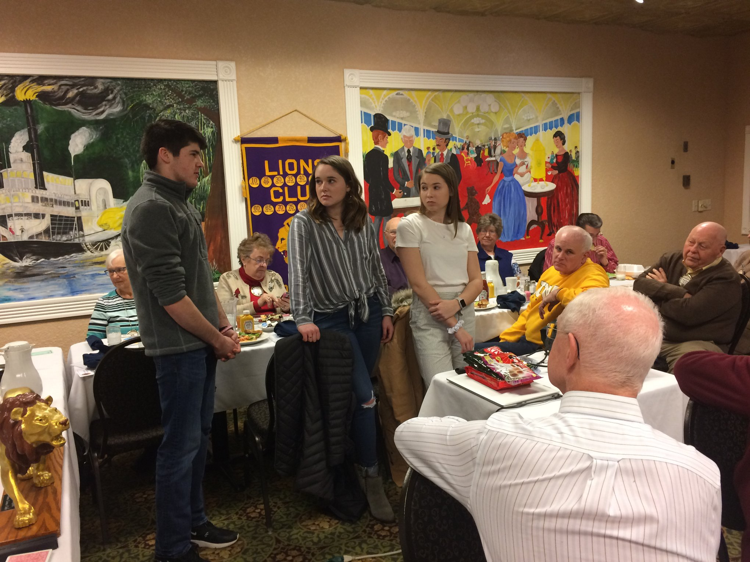

(Read additional background information about our Lions Club Student Advisory Board in the February newsletter.)

Future Student Advisory Board Schedule:

* March 7 – Washington High School
* March 21 – Spring Break – No School
* April 4 – Jefferson High School
* April 18 – Kennedy High School
* May 2 – Washington High School
* May 16 – Jefferson High School

**REMINDER: NEW MENU CHOICES**

To order from the Limited Menu, you should **place your order by 11:40am** so it will be delivered to the room by 12:00 noon.

* **$3.00 Beverage service only – REMINDER: if you do not order food, you must still pay $3.00.** 
  + Note: the Longbranch does not charge us for meeting space , set-up, or storage space; they do now require attendees pay for either beverage service or one of the below food options.
* **$10.50 Soup and Salad Buffet** (salad bar, soup, bread)
* **$14.50** **Complete Lunch Buffet** (salad bar, soup, two entrees, vegetables, bread, dessert)
* **$14.50** Limited Menu choices (must place order by 11:40am for delivery by 12:00 noon):
  + **Cran-Apple Chicken Salad** on a bed of fresh greens with seasonal fruit, roll
  + **Wedge Salad** (with diced tomato, red onion, green onion, bacon, bleu cheese dressing, roll)
  + **Reuben Sandwich** (corned beef, sauerkraut, Swiss cheese, on pumpernickel) with French fries or cottage cheese
  + **Breaded Pork Tenderloin Sandwich** (tenderloin, pickles, onions, ketchup, mustard) with French fries or cottage cheese
  + **Classic Cheeseburger** (⅓ lb all beef patty, American cheese) with French fries or cottage cheese
  + **BLT Sandwich** on Texas Toast with French fries or cottage cheese

**World Hearing Day 2019: Check Your Hearing**

This year’s World Hearing Day theme from the World Health Organization (WHO) is “Check your hearing!”. On World Hearing Day 2019 (March 3), WHO will draw attention to the importance of early identification and intervention for hearing loss. Many people live with unidentified hearing loss, often failing to realize that they are missing out on certain sounds and words. Checking one’s hearing would be the first step towards addressing the issue.

The Iowa Lions Hearing Aid Bank collects and distributes used hearing aids.If you know someone who cannot afford hearing aids the Lions of Iowa may be able to help! The hearing aids you will receive are used and fit behind the ear. You need to live in Iowa to be eligible for this program. The application goes through a local Lions Club coordinator – our club coordinators are Bill Jurgensen and John Swenson. Once approved the club coordinator will direct you to an office that works with the Lions. “Can you hear me now??”

**Childhood Cancer chairs, Dennis Egel and Gary Glockhoff**

We owe a big thank you to Dennis and Jennifer Egel for delivering our valentines cards to the pediatric cancer patients at Staed Hospital in Iowa City. We should never underestimate the importance of small kindnesses when supporting those who are in most need. Thanks to everyone who signed the cards.

**March is Eye Donor Awareness Month**

The month of March is a special time to honor eye donors and their families for giving the gift of sight. Eye donations are crucial for research and education, as well as corneal transplants that can help restore the sight of children and adults. Are you an organ donor?

Lions Eye Banks recover, evaluate, store and distribute human eye tissue for sight-saving procedures. The Iowa Lions Eye Bank in Iowa City has been in service for 64 years. In 2018, the state of Iowa had 973 cornea/eye donors; 791 donor corneas were provided for sight restoring surgeries.

**From our Diabetes Chair, Margaret Debner**

**SHOULD I DRINK THAT SODA?** Diabetes Committee info

The volume of soft drinks consumed in the United States has increased by 5x since 1950. Not only the

number of servings but the sizes of the serving have climbed dramatically. The average size of a

beverage in 1950 was 7 ounces; currently the average size varies from a 12 oz. can to a 32 oz. big gulp

often with free refills.

The amount of sugar in a small portion is equal to the total recommended amount of sugar in the daily

diet. The recommended sugar calorie consumption is 100 calories for a female and 150 calories for a

male per day. It is not just the usual number of calories that has risen but also the “added sugars.”

“Added sugars” mean all types of concentrated sugar-based sweeteners, including cane sugar (white or

brown), high fructose corn syrup, molasses, fruit juice, maple syrup, honey, and other syrups such as

agave, corn, rice or sorghum.

Artificially sweetened beverages might not be a much better choice. Many people turn to soft drinks

made with zero calorie sweeteners. While these drinks tend to be essentially calorie-free, they may still

raise your risk of developing diabetes.

In an article published in June 2014 in the British Journal of Nutrition, researchers found the combined

results of multiple studies showed about 11 ounces of soda that was sugar sweetened consumed daily

resulted in a 20% higher risk of developing Type 2 diabetes. For the same quantity of artificially

sweetened soft drinks (artificial or natural sweeteners) the risk was 13%.

The recommendation from the scientific community is “drink water” which the body needs to function

properly, eliminate waste, and maintain cell health. The cost is very little, the benefits are many, and the

risks are generally low unless other contaminants are present.

Information comes from the Diabetes Self-Management edition published January 2019.

**MINUTES-CEDAR RAPIDS NOON LIONS BOARD**

**February 20, 2019 10:30 am Longbranch Convention Center**

**Attendance:** Kristin Glockhoff, Mary Doyle, Margaret Debner, Ron Mustaine, Walt Hartman, Gary Glockhoff, Dennis Egel

Committee Chairs: John Swenson, Rich Rheinschmidt, Barb Taylor, Mary Ann Dawson, Margaret Debner,

Past President: Greg Reed

**Call to order** by President K Glockhoff, 10:30 am

**Agenda approved:** motion M Debner, W Hartman second, carried

**Minutes approved:** motion G Reed, W Hartman second, carried

**Financial Reports:** Balances on hand are: Administrative account, $8,856.10; Charity account, $1,232.86; Total Memorial Fund account, $45,060.42; Balance of all accounts $55,149.38.

**Correspondence:** A letter was received from Hannah Kettler, ASAC, requesting time to speak to the club about volunteer opportunities. Her request was passed on to program chairs.

**STANDING COMMITTEE REPORTS:**

**Membership:** T Durham: no report

**Vision:** R Rheinschmidt, co-chair: In January 2 Lions @ 9 hours. served 5 adults. Funds donated $180, YTD $675.

**Hearing:** John Swenson, co- chair:One person is being tested and another application is currently being processed.

**KidSight:** B Taylor, M Dawson co-chairs: In January 6 Lions @ 20 hours screened 171 children, YTD 1678 children screened. There have been many school cancellations this month due to the weather. Screenings have been scheduled.

B Taylor and M Dawson have begun to write a job description for the KidSight chairperson.

**Wright School partnership:** M Debner, co-chairs: In January 5 Lions worked with 45 students, tutoring or visiting lunch buddies.  Due to the many weather related school cancellations fewer volunteer hours will be recorded in February. Library books to be purchased with Lion Club funds have been ordered. $20 gift cards for teachers have been purchased and will be given at a school assembly (perhaps March).

**Diabetes:** M Debner continues to write articles about diabetes for the club newsletter.

**Childhood Cancer:** D Egel, G Glockhoff: Valentines from the club were delivered to children at the Children’s Hospital, UIHC.

**Environment:** R Mustaine: No report

**Hunger:** W Hartman shared preliminary information from Meals from the Heartland.  The Cedar Rapids Hunger Fight event will take place in Cedar Rapids on June 14 & 15. More information is needed regarding team organization and donations before the club commits to this project.

**OTHER COMMITTEE REPORTS:** No reports

**OLD BUSINESS:**

A February Fundraiser letter has been distributed to all members.

**Response to Gazette:**

Gazette has offered us space for a guest column to include information about KidSight, the Wright School Partnership, celebrating 100 years, and the possible new club at Newbo.

The Gazette is willing to offer free advertisement for the Lions Variety Show.

**Hospitality Rooms State Convention June 7 & 8, 2019**

Gary and Kristin Glockhoff, Terry Durham, Mary Ann Dawson, Jim Russell and Barb Taylor have volunteered to run the hospitality rooms at the state convention.

**NEW BUSINESS:**

**New officers for next year:**A nominating committee, including the 1st vice-president will put together slate of officers for next year.

**Awards Banquet: Friday, April 26, 2019**

**T**he banquet planning committee members are K Glockhoff , M Debner, D Egel, and A Huneke.

**100 Year Celebration: May 23, 2020**

T Durham and G Glockhoff are working on plans for the 100-year celebration of the founding of the Cedar Rapids Noon Lions Club.

Adjourned at 11:15 am

Respectfully submitted,

Mary Doyle, Secretary

**Events Calendar:**

# *Board Meeting Schedule = 3rd Thursday of each month at 10:30AM*

* March – Eye Donor Awareness Month
* 03 Mar 2019 - World Hearing Day
* April – Environmental Awareness Month
* 26 April 2019 - Arbor Day (Environment)
* May – Strengthen Membership Month
* 01 June 2019 – Helen Keller Day
* 05 June 2019 – World Environment Day
* 06 June 2019 - National Hunger Awareness Day
* 07 June 2019 – Lions Clubs International Birthday
* 07-08 June 2019 - State Convention - Host Hospitality Rooms
* 05-09 July 2019 – 102nd International Convention (Milan, Italy)
* 06 May 2020 – 100th ANNIVERSARY OF CEDAR RAPIDS NOON LIONS CLUB

**Web Addresses**

**Lions International** [**www.lionsclubs*.org***](http://www.lionsclubs/)

**Iowa Lions Website** [**www.iowalions.org**](http://www.iowalions/)

**Iowa Lions Newsletter** [***www.iowalions.org/theiowalion.html***](http://www.iowalions.org/theiowalion.html)

**District 9EC** [**www.iowalions*9ec.org***](http://www.iowalions/9ec.org)

**Cedar Rapids Noon Lions Club…………https://www.cedarrapidsnoonlionsclub.com**